Experiment 7: Students Attendance System
Aim
To create a simple cloud-based Students Attendance System using a cloud service provider to demonstrate SaaS.
Algorithm
1. Open Zoho Creator and create a new application.
2. Create a form named Students Attendance System.
3. Add fields such as Student Name, Register Number, and Course.
4. Add an Attendance Status field with the options Present and Absent.
5. Add fields for Course Attendance and OD Request.
6. Add fields for Attendance Percentage and Grade.
7. Calculate the attendance percentage using the number of classes attended and the total number of classes.
8. Save the form and publish the application.
9. Enter attendance details and view the submitted records.
Implementation
Input
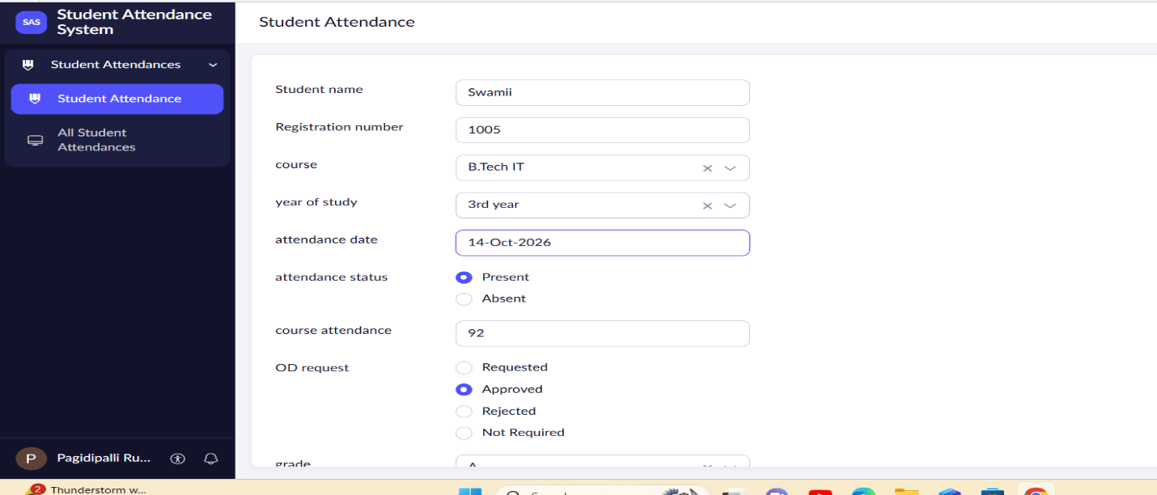

Output
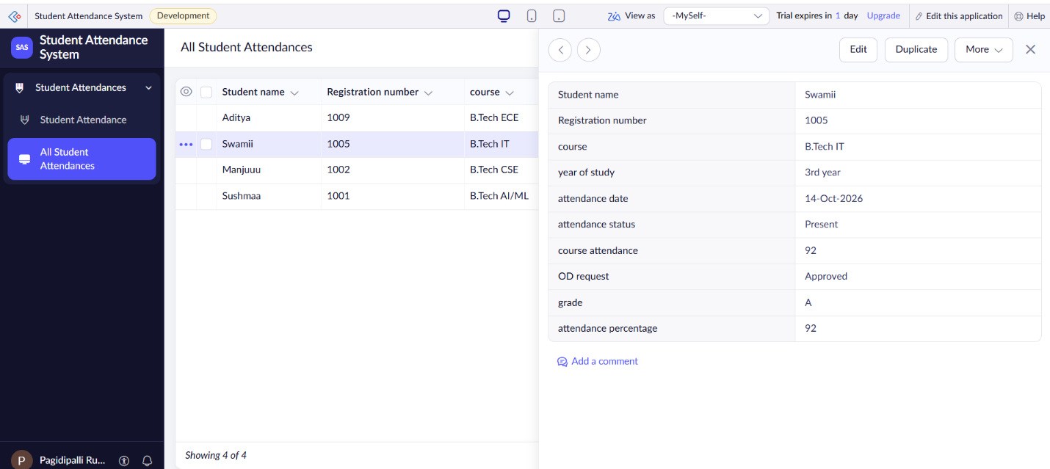

Result
Thus, a cloud-based Students Attendance System was created successfully to record student attendance and manage attendance percentages.

